Topic 5

Designing learning and assessment materials for content-language learning

Key concepts to learn

Concept 1: Students have to use the language to learn both the content and the language. Language use is productive learning. Receptive learning, by simply listening to the teacher or even reading, is not as effective as productive learning, where students have to produce a product.

Concept 2: Students have to be taught to use the language to show their learning. Simply teaching content and assuming that students can use the language to show their understanding will only result in students not being able to use the language at all.

Concept 3: Learning materials have to be designed with the understanding of the need to provide language support for students to help them learn to use the language. Text structures and related graphics provide very effective language support and information transfer activities (text → graphic → text) are particularly useful.

Concept 4: The principle of gradual release of scaffolding (language support) is important to help students to be gradually able to use more and more language on their own.

Workshop: Designing materials for content-language learning

Activity 1
Study the following information transfer activity and answer the following questions:
- What knowledge structure is represented in the activity?

- What graphics are used? How do the graphics relate to the knowledge structure?

- What language form is used?

- How are students helped to gradually be able to use the language form? What scaffolds are provided for the students to help?

- How many times do students have to use the language form? How likely is it that students can learn to use this form to talk about cause-effect?

Indicators
Cause
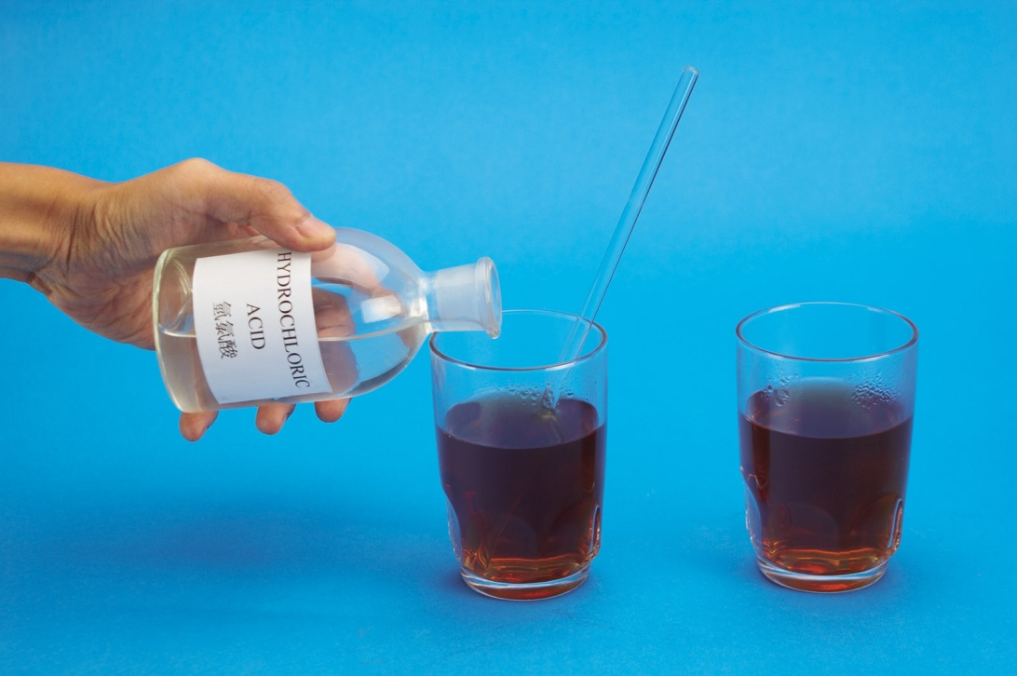  Cause |  | When we add dilute hydrochloric acid to tea,  the tea changes colour.  Effect
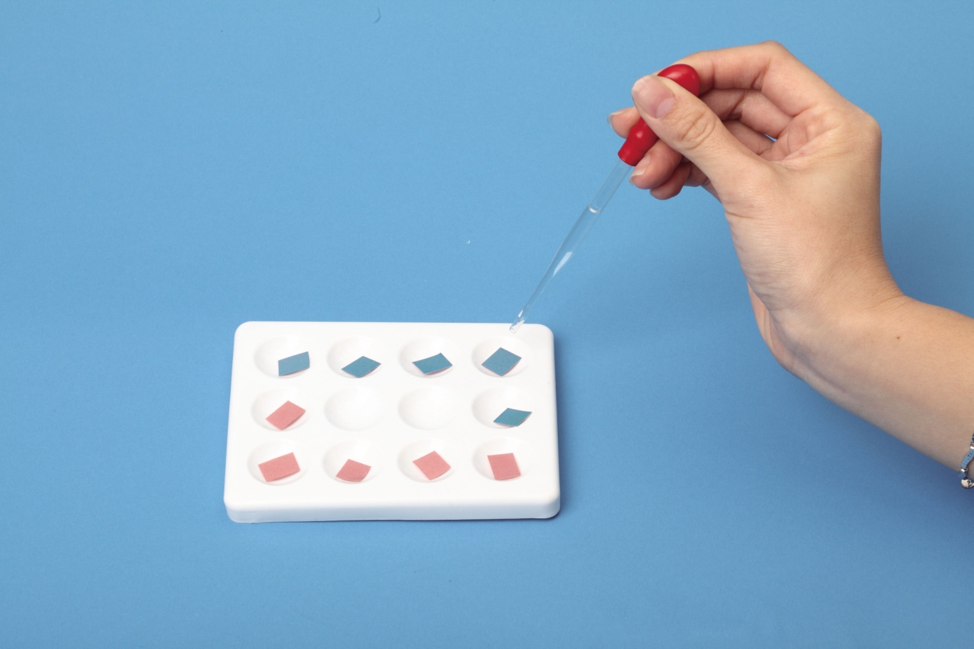  Cause |  | When we add dilute hydrochloric acid to red litmus paper,  __________________________________________________________  Effect
Cause |  | When we add dilute hydrochloric acid to blue litmus paper,  __________________________________________________________  Effect  Cause
   | Dilute  hydrochloric  acid | Distilled water | Dilute sodium  hydroxide  solution
  Colour change  of blue litmus  paper | RED | BLUE | BLUE
  Colour change  of red litmus  paper | RED | RED | BLUE
When we add dilute sodium hydroxide solution to red litmus paper,
__________________________________________________________
Effect
When we add dilute sodium hydroxide solution to blue litmus paper,
__________________________________________________________
Effect
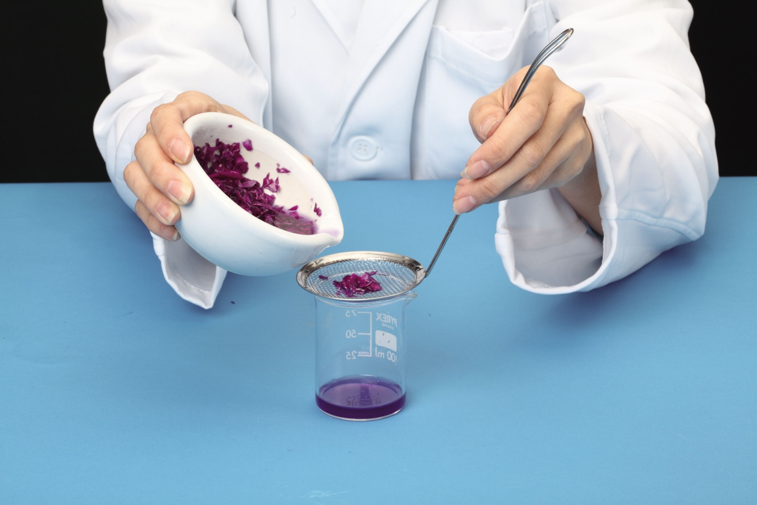  Cause  extract of red cabbage leaves  Cause |  | When _______________________________  ________________________________________________________ ,  the extract turns reddish purple.  Effect
Cause |  | When________________________________  ________________________________________________________ ,  the extract turns green.  Effect
  Plant | Distilled water | Dilute hydrochloric acid | Dilute sodium  hydroxide solution
  Red cabbage leaves | REDDISH  PURPLE | RED | GREEN
When__________________________________________________________________________________ ,
_____________________________________
Effect
Metal and Acid  - copper | ________________________________________________________________________________________________________________________________________
2. iron | ________________________________________________________________________________________________________________________________________
- aluminium | ________________________________________________________________________________________________________________________________________
4. zinc | ________________________________________________________________________________________________________________________________________  Cause
When _______________________________
________________________________________________________ ,
______________________________________
Effect
Metal and Acid  - chalk | ________________________________________________________________________________________________________________________________________
2. stone | ________________________________________________________________________________________________________________________________________
- building materials | ________________________________________________________________________________________________________________________________________

Activity 2
Comparing content support and language support in information transfer activities
The following are two versions of the same information transfer activity. Study them carefully and answer the questions that follow.

Breathing mechanism
The following diagrams show the process (i.e. what happens) when we breathe in and breathe out air.
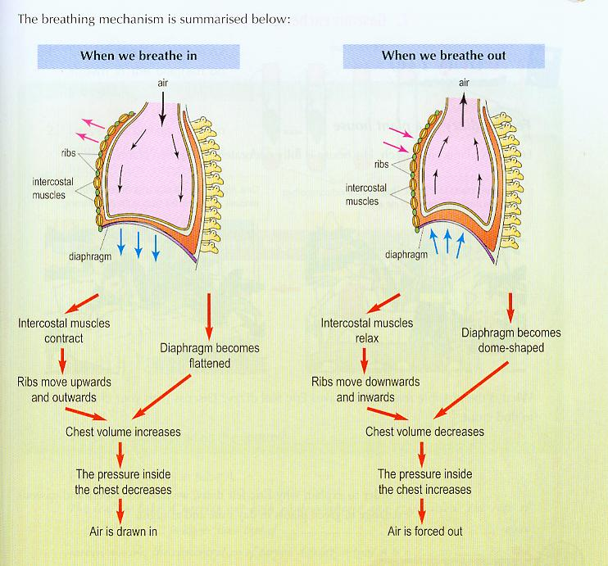

[Taken from Chan, W.K., Luk, W.Y., & Kong, S.W. (2005). Understanding integrated science for the 21st century. Hong Kong: Aristo Educational Press Ltd.]

Version 1
Use the diagrams to complete the following text:

When we breathe in and out, air is forced into and out of the lungs by the ______________ muscles, the ribs and the ______________.

When the intercostal muscles __________, the ribs move _________ and __________ and the diaphragm becomes ___________. This causes the volume of the chest to ___________ and the pressure inside the chest therefore _____________. Air is thus drawn in.

When ___________________________, the ribs move ___________ and _________ and the diaphragm becomes ______________. This causes ____________________
_______________ and pressure inside the chest therefore ___________. Air is thus pushed out.

Version 2
Use the diagrams to complete the following text:

__________ we breathe in and out, air ________________________ of the lungs by the intercostal muscles, the ribs and the diaphragm.

_________ the intercostal muscles contract, the ribs move upwards and outwards and the diaphragm becomes flattened. This _______ the volume of the chest to increase and the pressure inside the chest ____________ decreases. Air is _______ drawn in.

_________the intercostal muscles relax, ____________________________________
______________________________________________________________________________________________________________________________________________________________________________________________________

Questions
- What knowledge structures and text structure are represented in the text in the two versions? How does the graphic match with them?

Knowledge structures =
Text structure =
Graphic =

- What do students have to write in Version 1? What can they learn with this version?

- What is the key problem in the design of this version (consider the match between the graphic and what students have to write)?

- What do students have to write in Version 2?

- Describe the language support provided in Version 2 and how the language support is gradually taken away. What can students learn from this version?

- Other than language support and the gradual release of language support, what should be another principle for the design of an information transfer activity that can lead to student learning (Hints: (1) copying will probably not lead to learning; thinking is important for learning. (2) consider how the graphic and the text can complement / supplement rather than overlap)?

Activity 3
Designing an information transfer activity

Text 1: Reading text
Aerobic and anaerobic respiration
The most efficient form of respiration is aerobic respiration: this requires oxygen.
Glucose + Oxygen = Carbon Dioxide + Water + Energy
This word equation for aerobic respiration means: "sugar and oxygen are turned into carbon dioxide and water, releasing energy".

When oxygen is not available, some organisms can respire anaerobically i.e. without air or oxygen. Yeast can respire in both ways. Yeast gets more energy from aerobic respiration, but when it runs out of oxygen it does not die. It can continue to respire anaerobically, but it does not get so much energy from the sugar. Yeast produces ethanol (alcohol) when it respires anaerobically and ultimately the ethanol will kill the yeast. This is the word equation for anaerobic respiration in yeast.
Glucose = Carbon Dioxide + Ethanol + Energy

We can respire in both ways too. Anaerobic respiration takes place when you exercise. When you exercise hard, your muscles need to release more energy from glucose and your body can't get enough oxygen to the cells. So, you use anaerobic respiration. This is where the body respires without oxygen and produces lactic acid. In anaerobic respiration the glucose is only partially broken down, and lactic acid is produced - together with a much smaller amount of energy. Your cells cannot respire anaerobically for very long because lactic acid is poisonous, causing pains and cramp in your muscles. To get rid of the cramp, we have to breathe very deeply for a few seconds to break up the lactic acid.

Graphic: Complete the design of the following table for students to read the text to get the key differences between aerobic and anaerobic respiration in humans.

 | Aerobic respiration | Anaerobic respiration
Oxygen supply | Requires ______________ | Does not require ______________
Condition under which it takes place | When there is enough _________ supply. | When you need more ___________ but have less _____________ supply than you need.

Text 2: Design a writing activity for students to write a comparison-contrast text to explain the differences between aerobic and anaerobic respiration in humans using the information in the table.
N.B.:
- A comparison-contrast text has 3 parts:
Statement of comparison^ [state that aerobic respiration and anaerobic respiration are different]
Points of comparison^ [compare each aspect of difference one by one]
Summary of comparison [summarise the main differences]
- Language use:
  - parallelism
  - negation
  - comparative connectives and conjunctions
  - comparatives

What language support do you need to provide students with to enable them to do the writing activity?

Now, design a learning activity for the topic you have chosen.

Assessment
If students have to learn the English of the content at the sentence and text levels, they have to be assessed on their ability to use appropriate sentences and texts to demonstrate their learning of the content. If you do not assess students’ English in any way, you cannot expect students to pay any attention to the quality of their English in their learning and production. If you show them that it is important (by rewarding effective use of content obligatory English) then they should take it more seriously.

The same principles that apply to the design of learning materials for content-language learning apply to the design of the assessment materials.

There two main ways of assessing content and language.
- One mark that grades both the language and the content together. This means that to get a top mark, students must show that they can give a correct content answer using accurate content obligatory English.
- Two marks, one for content and one for English. The total of the two marks gives the final mark. You need to decide on the percentage allocation for the marks between content and language.

Consider ways in which you can include some assessment activities that will require students to show their ability to use the English of science. Think about:
- What percentage of the exam / test paper(s) will require the use of the English of science;
- How can this part that requires the use of language be added to the exam / test papers: as a completely additional part (in which case, how do you adjust the marks to other parts to include this, how many marks will be given to this part?); as a replacement of another part (which part can it replace, how many makes will be given to this part?)
- What other issues do you need to consider?

Checklist for learning activities
This checklist can be for self-evaluation or peer evaluation.

 |  | Yes/no
Is there a clear learning aim in the activity? | Objectives
Does the activity help students to learn something new rather than test what students already know? | Objectives
Do the students have to process knowledge (think rather than just recall or cut & paste) in order to complete the activity? | Objectives
Suggestions for improvements:

Is the activity language rich?  Do students have to use the English of the content to complete the activity? | Language
Suggestions for improvements:

Are the instructions for students clear and precise? | Procedure
Is the activity realistic? Can it be completed with the knowledge in the time available (a single or double lesson) with the class described? | Procedure
Suggestions for improvements:

Is the language suitably scaffolded?  Is scaffolding gradually released during the activity to enhance learning? | Scaffolding
Suggestions for improvements:

